DevOps Wiki Info

Tuesday, March 29, 2022

8:15 AM

## Basics

|  |  |
| --- | --- |
| * + Log in to Azure DevOps   + Open the HACR project   + Under "Overview", select "Wiki" | Azure DevOps  HACR  Overview  Summary  Dashboards  Wiki  Repos  Pipelines  Artifacts |
| * + Select a wiki page from the listing or click "New page" at bottom of the page list pane.     - Pages can be nested, so you can create 'sub-pages' if desired for some sort of hierarchy   + Click the vertical 3 dot button to rename or administer security for the wiki. | HACR.Wiki v  Filter pages by title  Home  + New page |
| * + Click "Edit" to load up the WSYWIG editor.   + Make changes in the left pane, and see immediate preview in the right pane.   + Hit "Save" if necessary, and "Close" to exit the "Edit" mode. | Home  o  Craig Setae 4h ago  Human and Compliance Resourcing (HACR)  HACR is a Human and Compliance Resource application replacement for zoho people.  General  PR-519  Development  ASP.NET Core 3.1 + Vue  Database  Follow  Edit |

## Editing

* Content is written using Markdown for simple formatting and parsing functionality
  + Markdown is basically just adding notations to plain text in the form of special character sequences
  + These tell a renderer to i.e. display specific text as bold, or make a hyperlink, without having to write HTML directly
* Files with Markdown content that should be rendered use the file extension ".md"
* Using the taskbar will add the correct notations to selected text for you if desired.
* For more complicated formatting, or something not available in the taskbar, see this reference:
  + <https://docs.microsoft.com/en-us/azure/devops/project/wiki/wiki-markdown-guidance?view=azure-devops>
  + Or: <https://www.markdownguide.org/cheat-sheet/>

## Super-Quick Reference

### 

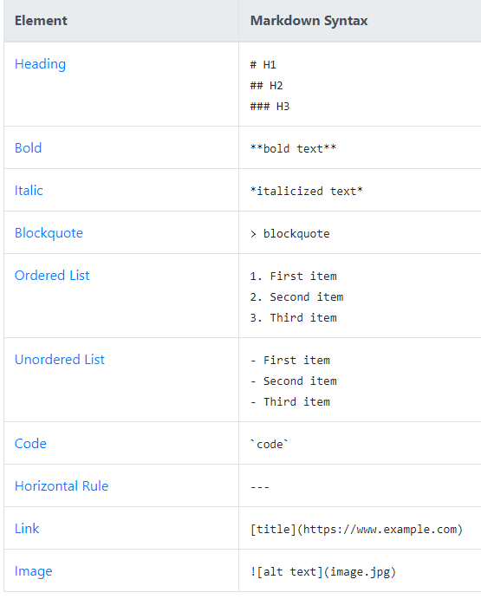

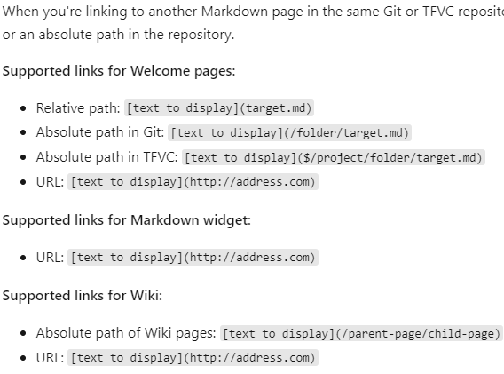

### 

Table 
Syntax I Description I 
Header I Title I 
Paragraph I Text I 
Fenced Code Block 
"firstName": "John" , 
"1astName": "Smith" , 
"age": 25 
Footnote 
Here's a sentence with a footnote. 
[Al]: This is the footnote. 
Heading ID 
my Great Heading {#custom-id} 
Definition List 
term 
definition 
Strikethrough 
%The world is flat.ææ 
Task List 
[x] Write the press release 
Emoji 
(see also Copying and Pasting Emoji) 
Highlight 
[ ] Update the website 
[ ] Contact the media 
That is so funny! :joy: 
I need to highlight these 
-very important 

## Escaping Special Characters

Escape Characters

Syntax 
To insert one of the following characters, prefix with a 
Enter to get # 
Enter to get ( 
Enter to get ! 
Example/notes 
Some examples on inserting special characters: 
(backslash). 
, backslash 
, backtick 
, underscore 
O , curly braces 
[ ] , square brackets 
() , parentheses 
# , hash mark 
+ , plus sign - , minus sign (hyphen) . , period 
! , exclamation mark , asterisk 
Enter to get \ 
Enter to get 
Enter to get 
Enter 
* to get 

## Special Azure DevOps Wiki Functionality

* Reference the documentation for the right notations to generate:
  + A Table of Contents
  + Mermaid diagrams
  + Gantt/Flowcharts
* When editing a page, click the ellipsis on the editing taskbar to view options to insert ToCs, videos, YAML tags, and other stuff.

## Azure DevOps Content Linking

* You can link or reference content all over the DevOps platform
* Link Work Items To Page
  + On a given page, click the 3-dot-button at the top right of the page viewer and select the option to "Link Work Items To Page".
* Reference Work Items in page
  + Typing "#" will give you the option to autocomplete with a work item number
* Add page reference to page
  + Click the ">>" arrows at the bottom of the page to expose the page listing, and drag/drop any page name to the editor to insert a link.
* Add files
  + Drag/drop works for files, images too
* Clipboard Image to page
  + Images in the clipboard (screenshots, etc.) can be pasted straight into the edit window(!)
* @<person> can be used to reference someone

## Other Notes

* If for some reason you wanted to do some admin activities from the CLI, you can open, retrieve, add, edit and delete pages using operations under "az devops wiki ###" in the Azure SDK
* You can view revision history by selecting "View Revisions" on the context menu of the page
* You can set up notifications for when a wiki changes by clicking the "Follow" button at the top of a given page
* You can create new work items from wiki text content by highlighting the text and clicking "New Work Item"